1. Create a P-T-S VPN and attach a VM to it.

* I have created Vnet and VM and I have created a VPN and created ROOT and CLIENT certificates. I have connected to that VM and gave CLIENT certificate to the VM.

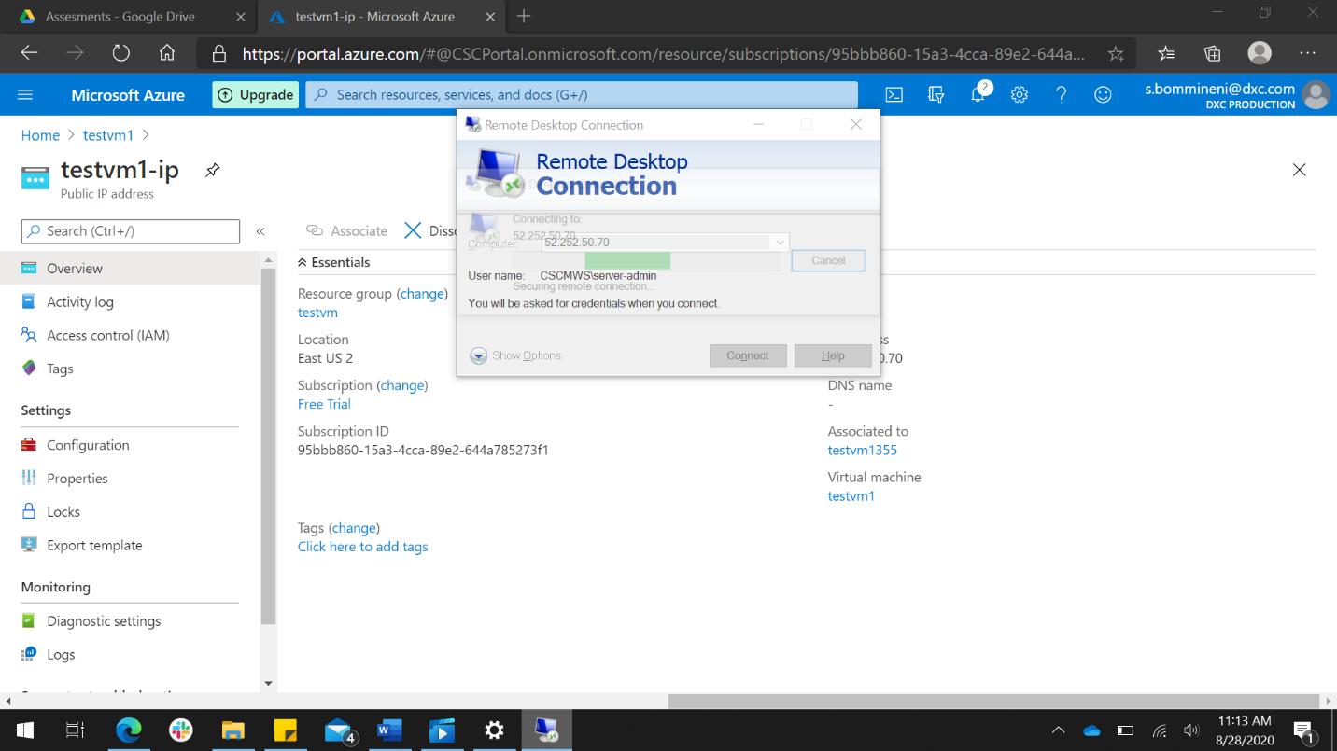

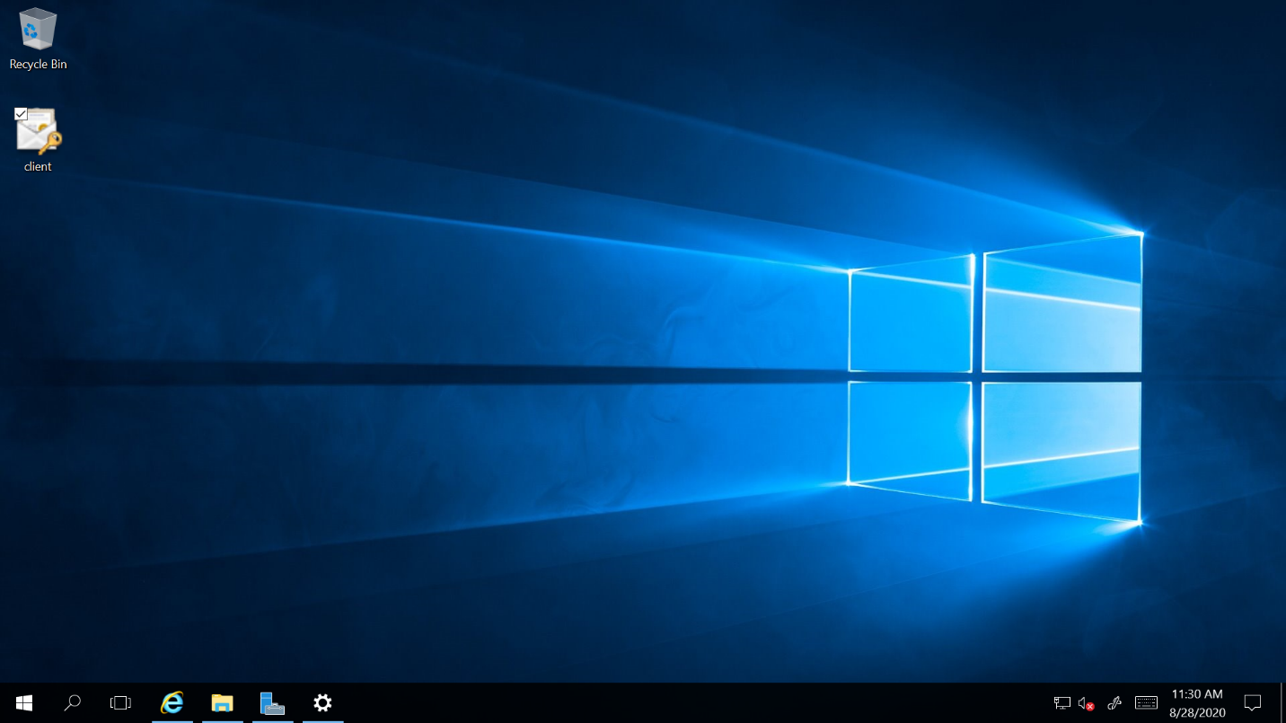

* I have downloaded VPN client in VM and connected to the VPN.

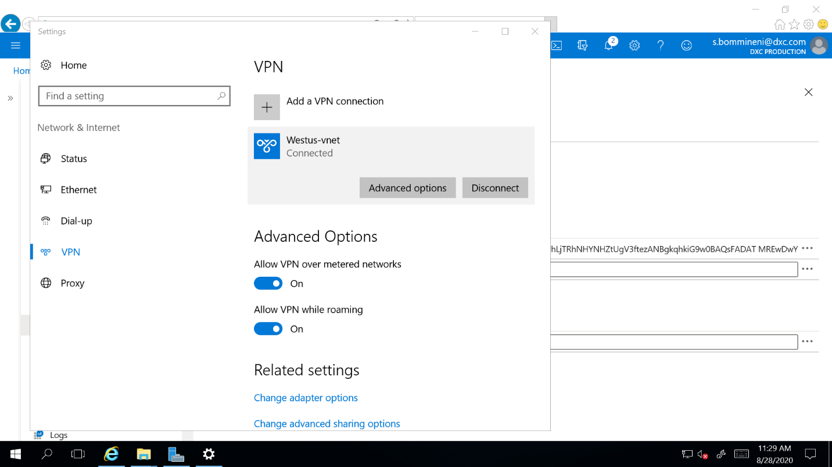

1. Create two web applications in west us and central us then attach to the traffic manager with priority routing method.

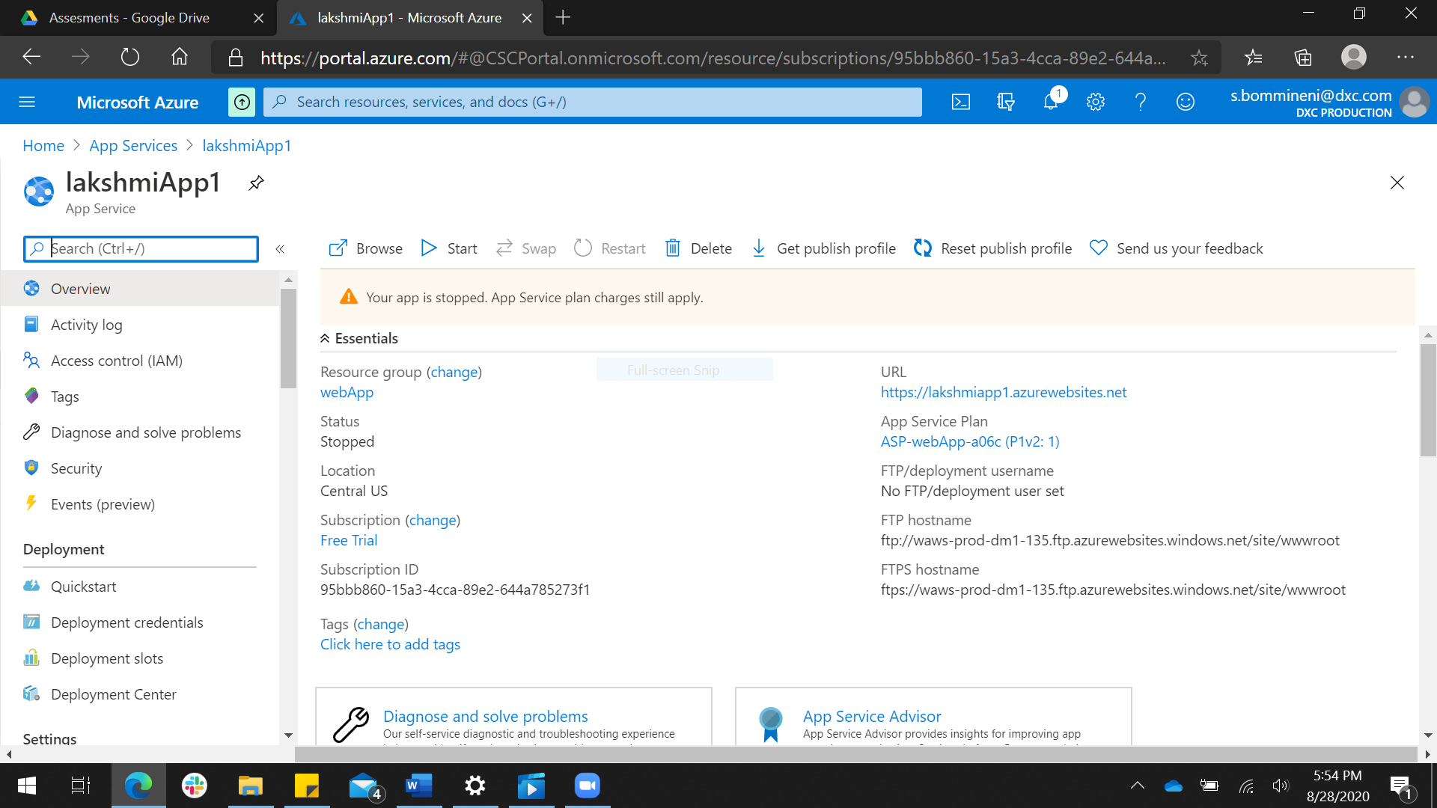

* I have created two web apps one in central us and other in west us.

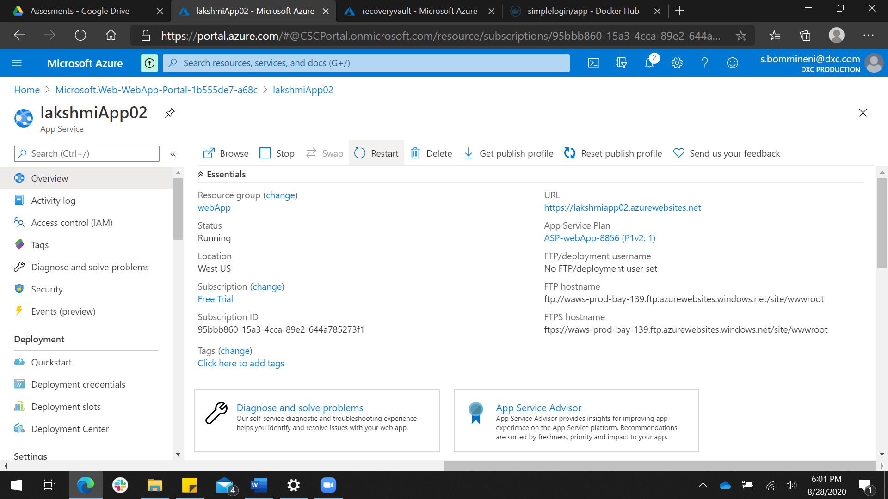

* I have created a traffic manager and attached two web apps to traffic manager.

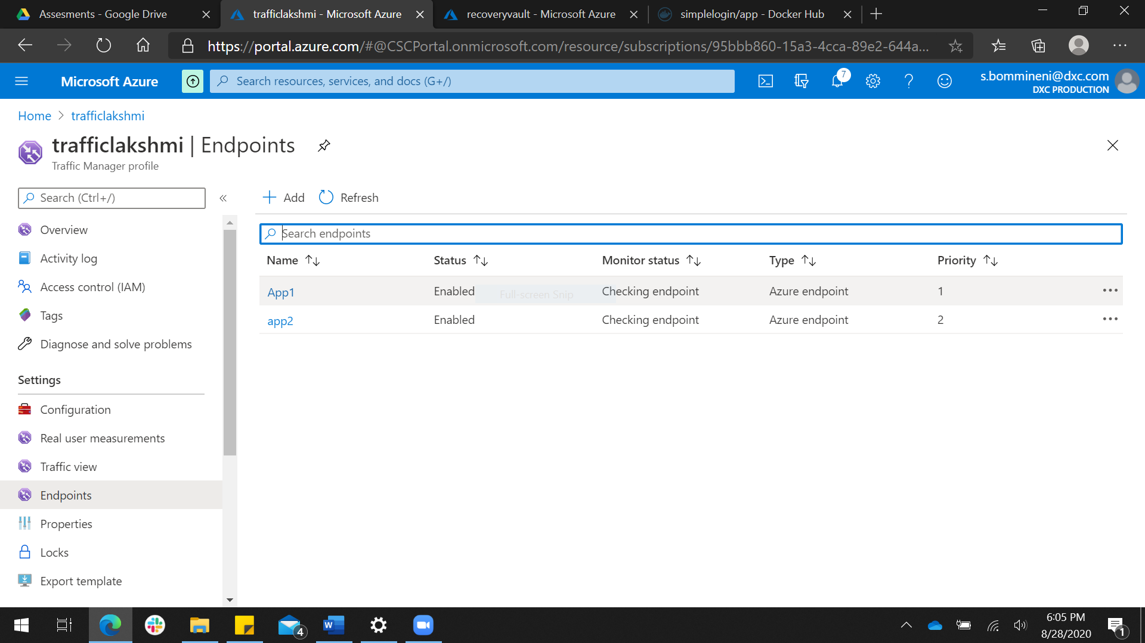

1. Create a windows server with AD installed and integrated with Azure AD.

* I have added roles and features in server manager in VM and downloaded Azure active directory connect.

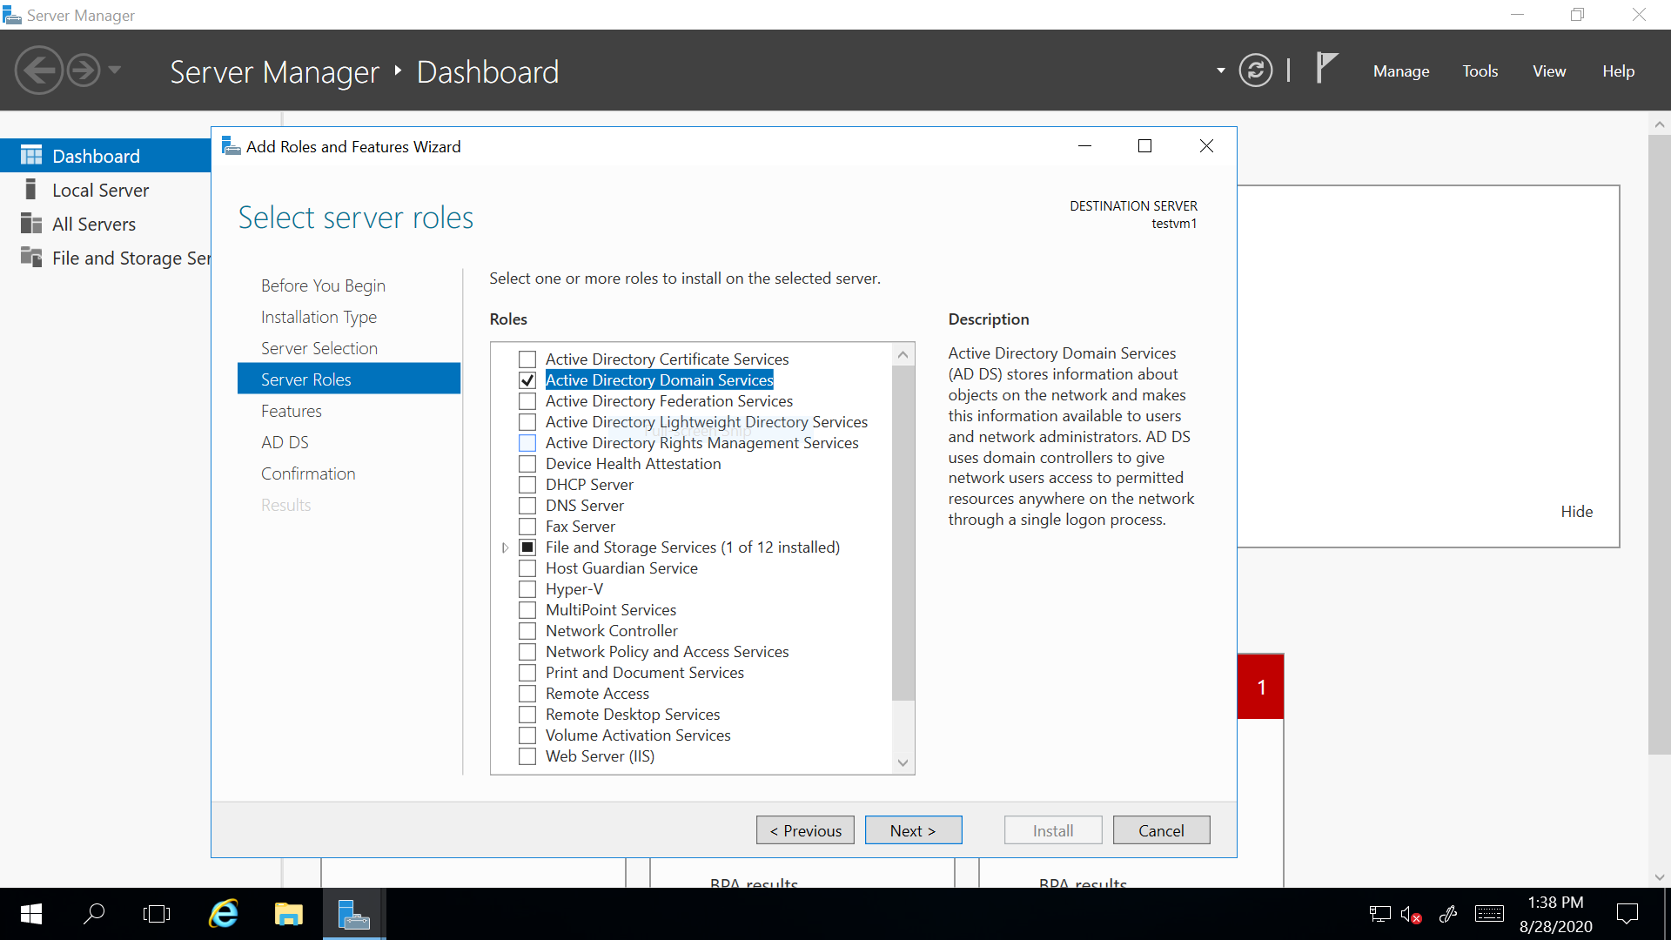

* I have created a user and assigned role as global administrator and integrated with Azure active directory.

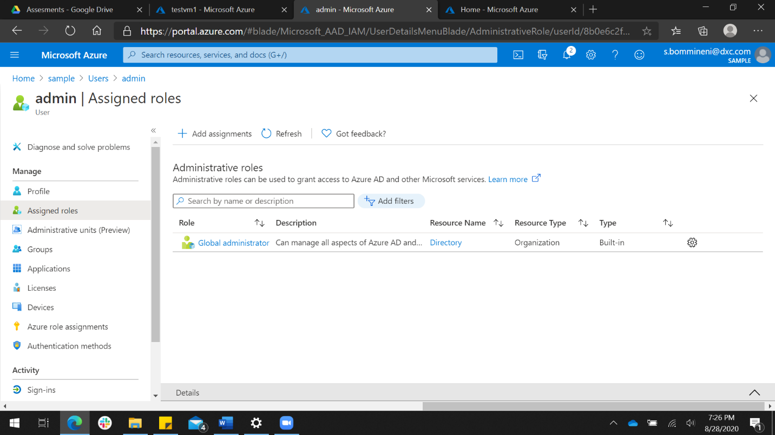

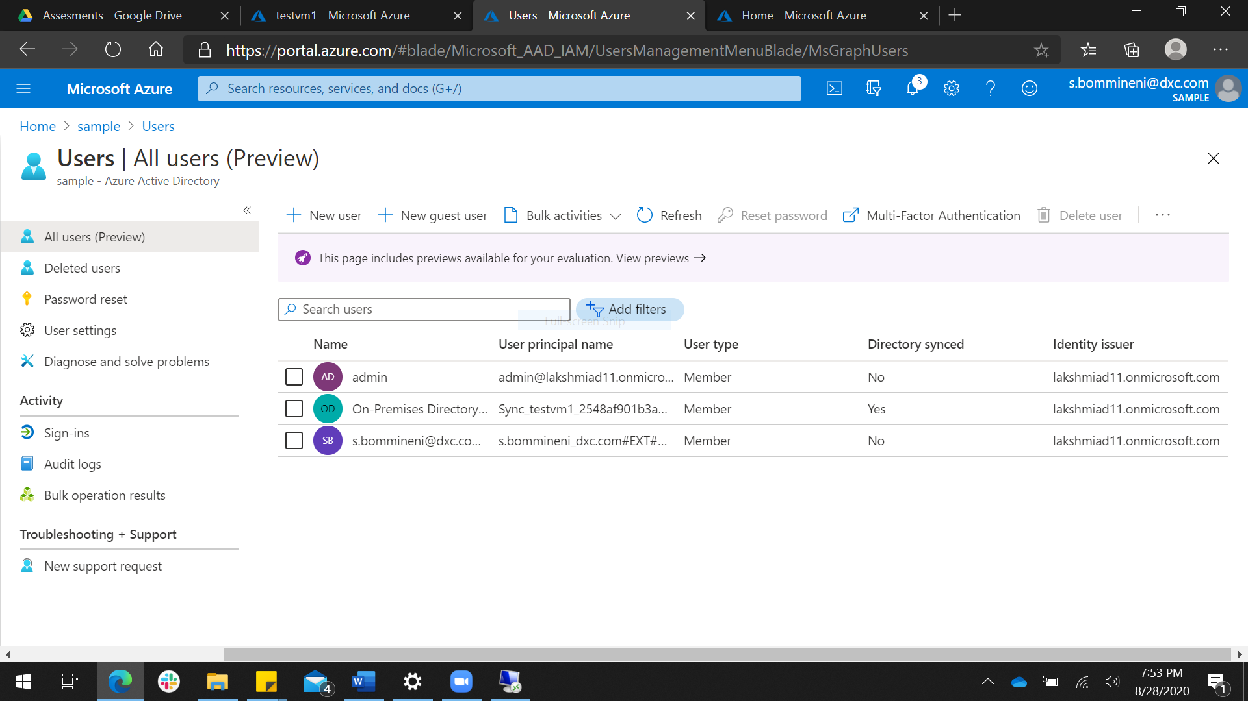

1. Configure a backup to the VM you installed AD.

* I have back up the VM with Active directory installed.

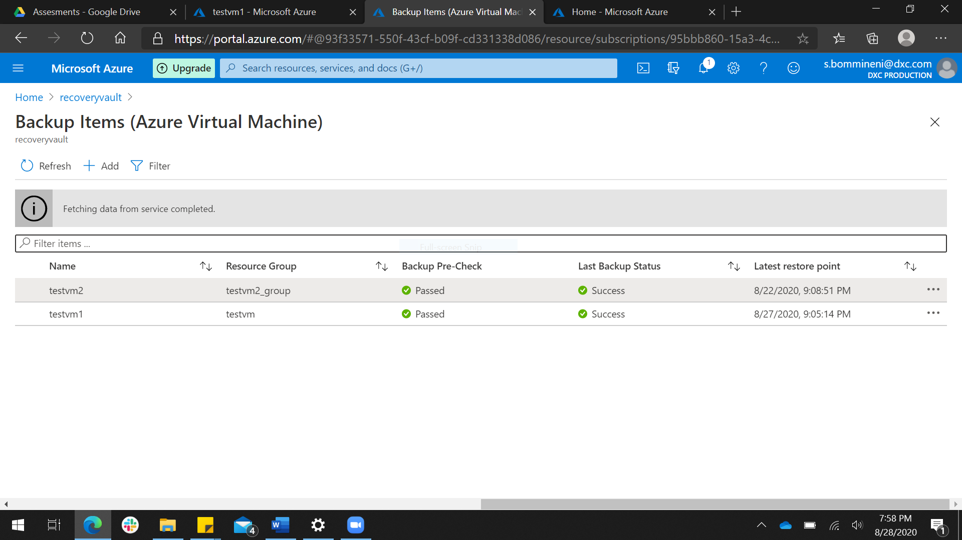

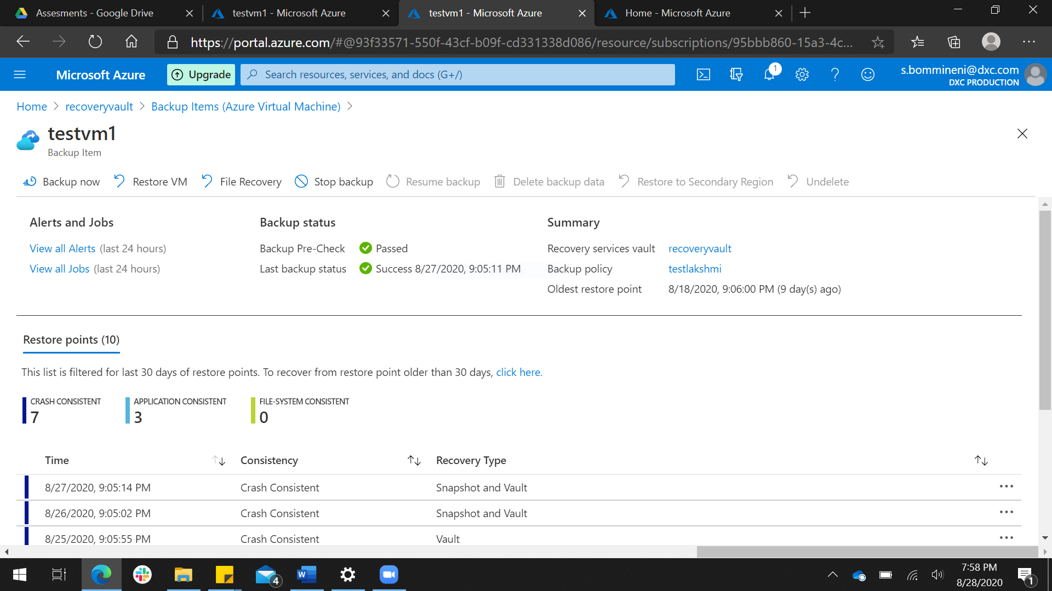

1. Configure alerts for the VM.

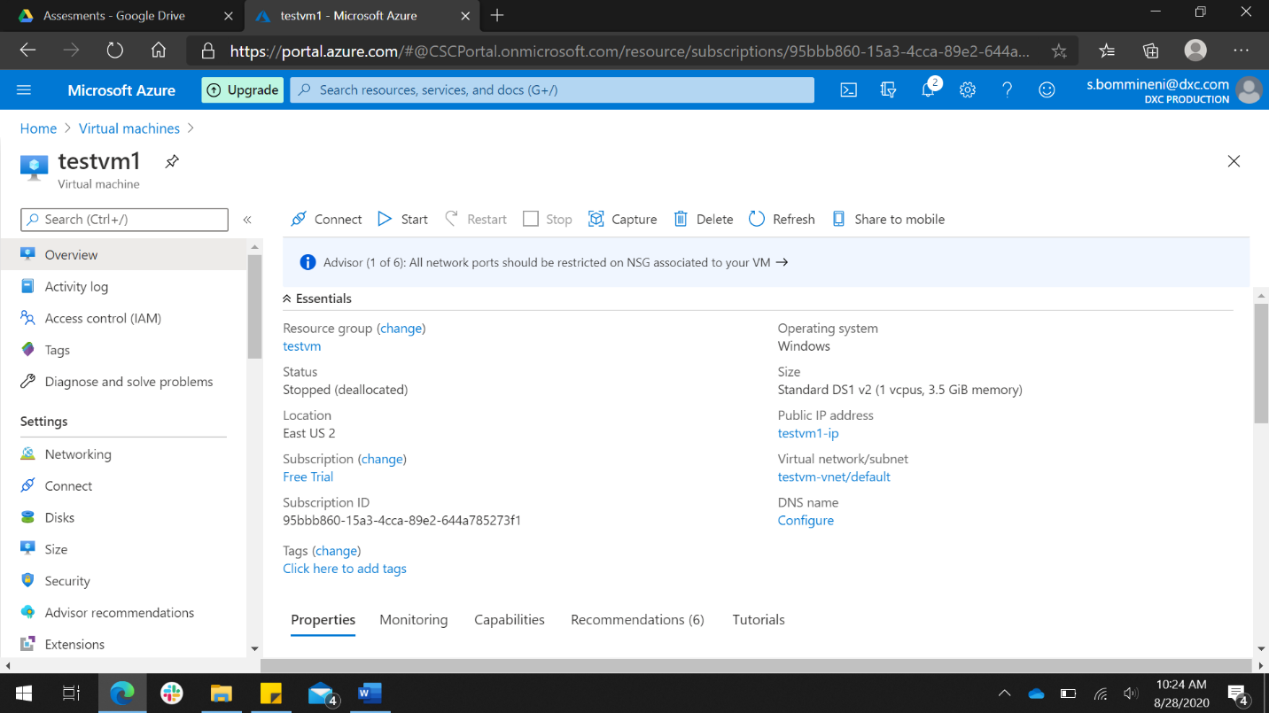

* I have created a VM with name testvn1.

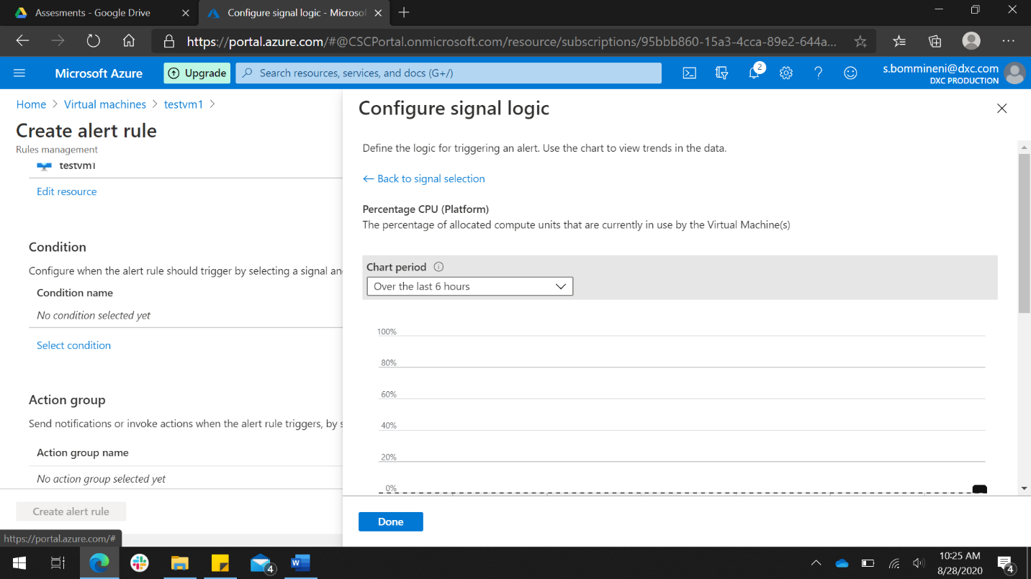

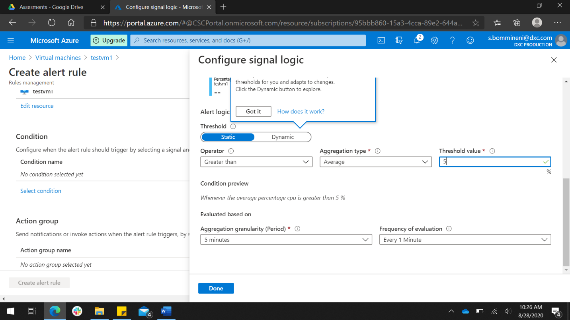

* I have created alert for percentage CPU (whenever average percentage is greater than5% the alert will be sent to the specified mail id.

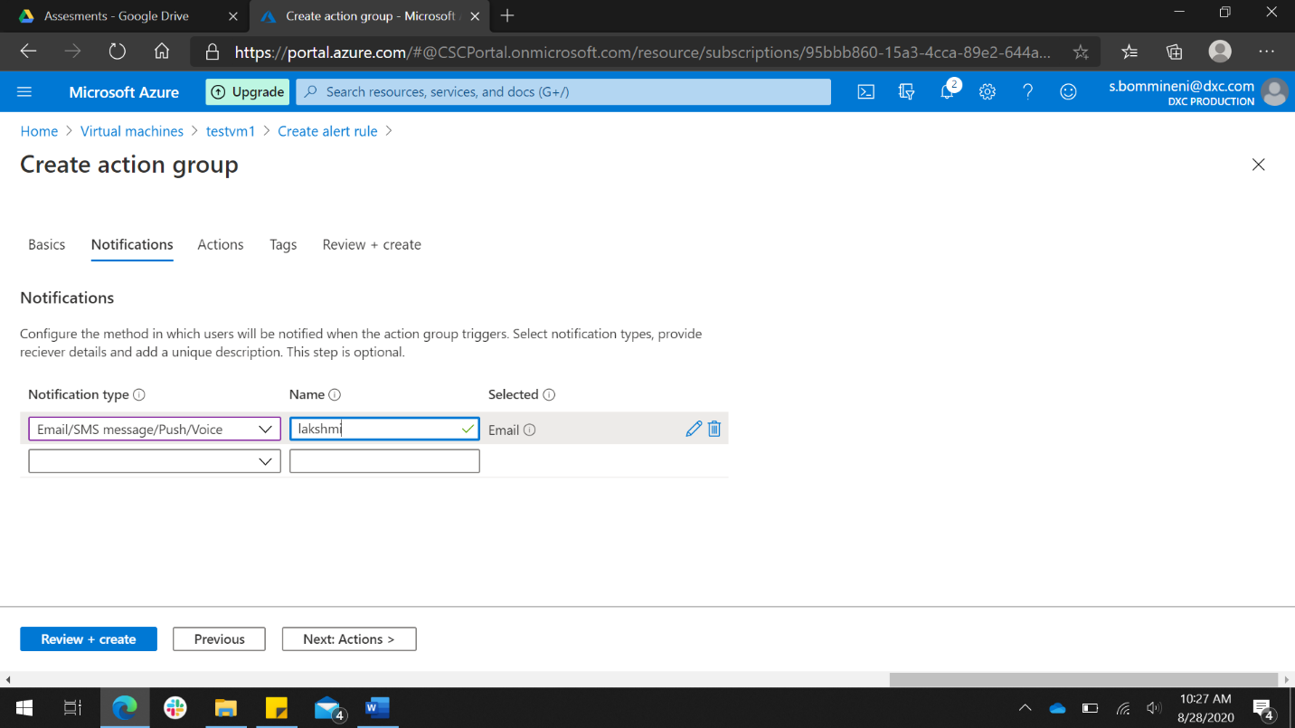

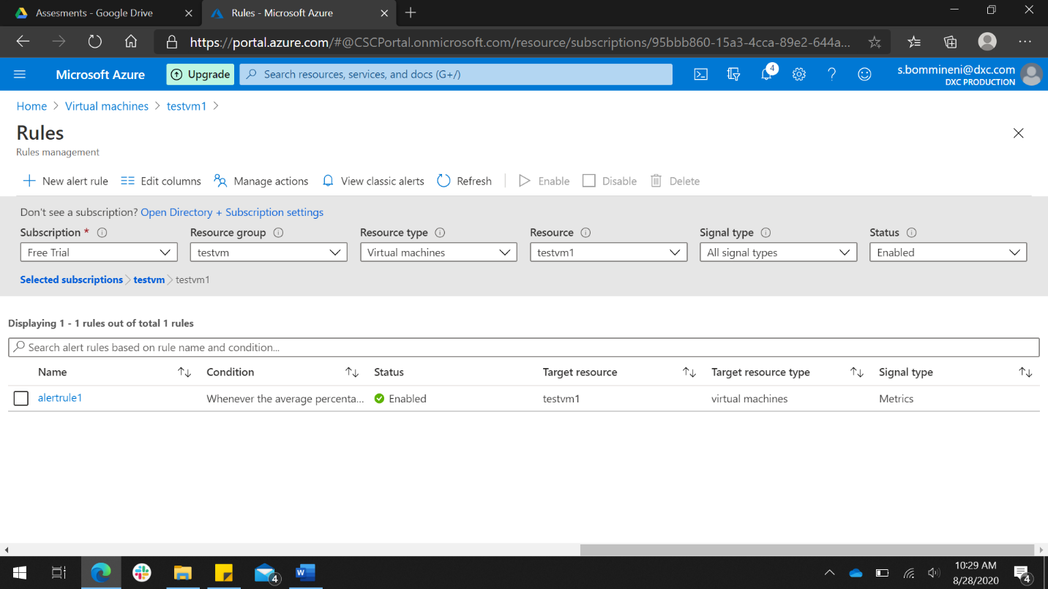

1. Apply any security policy to the subscription.

* In security center I have selected the subscription and then I have added a custom initiative.

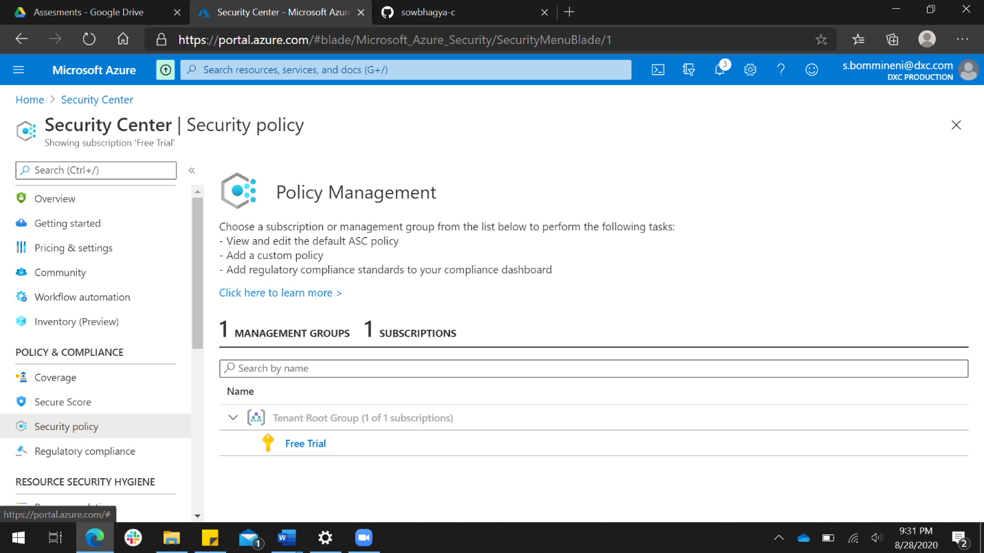

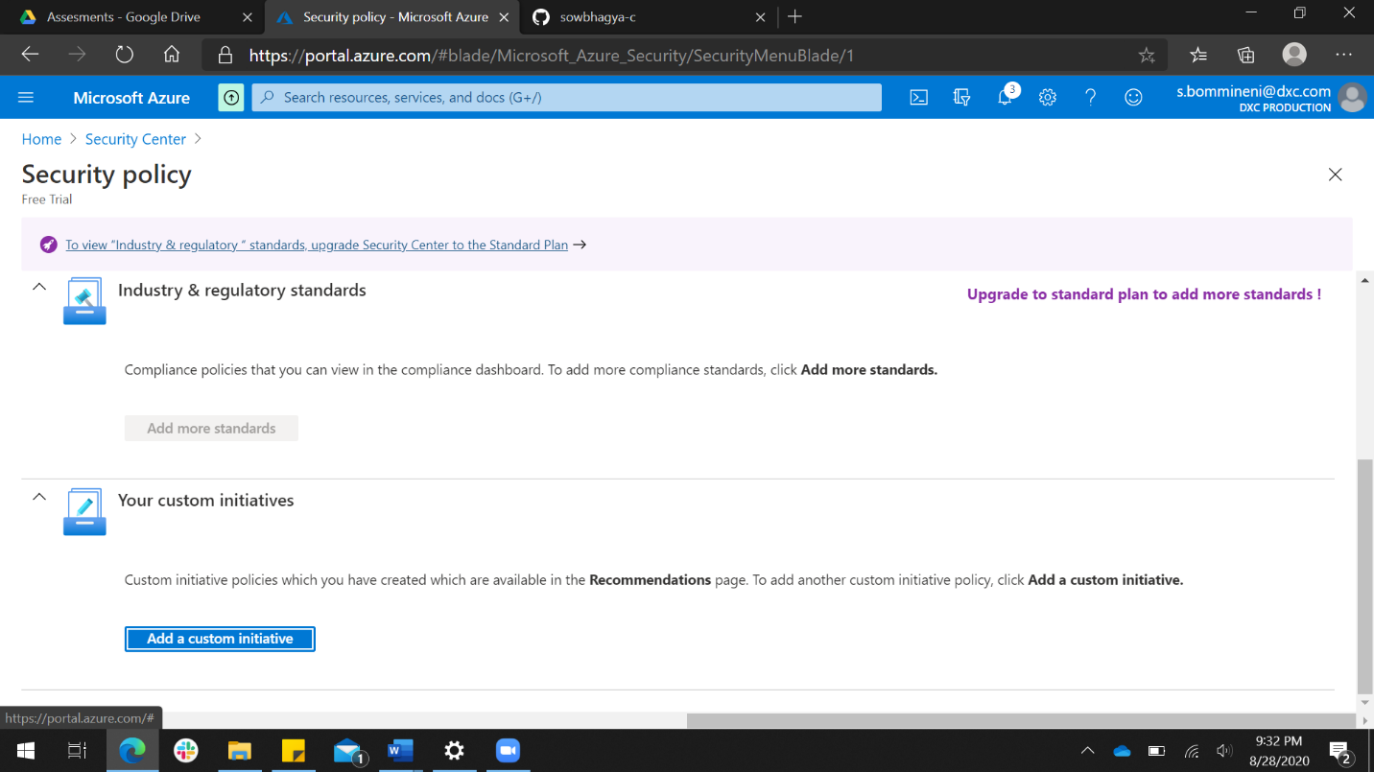

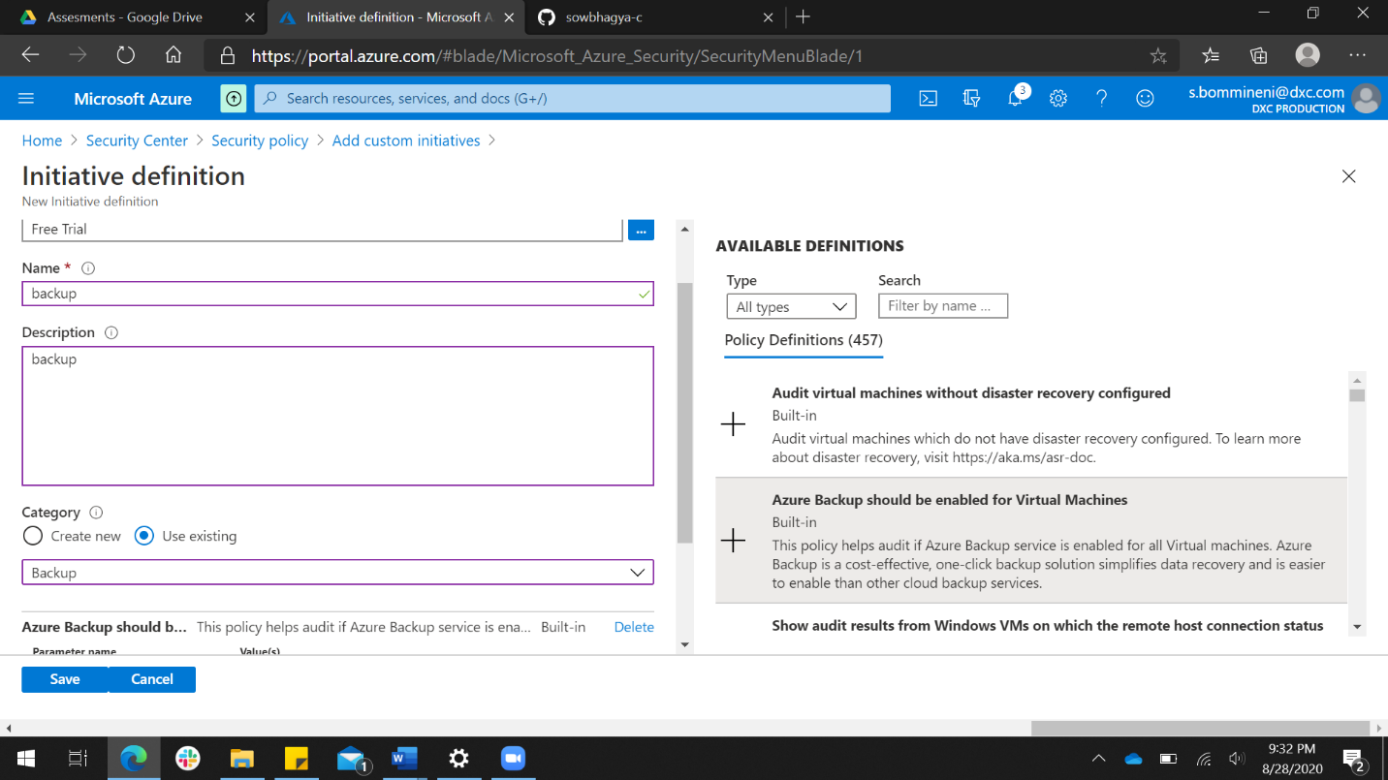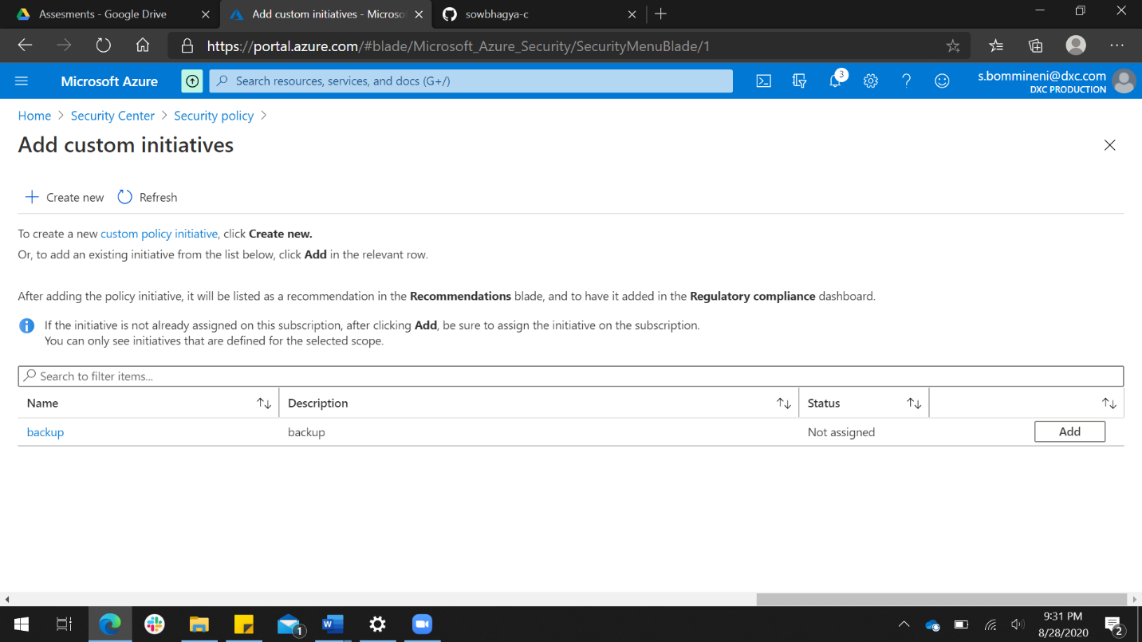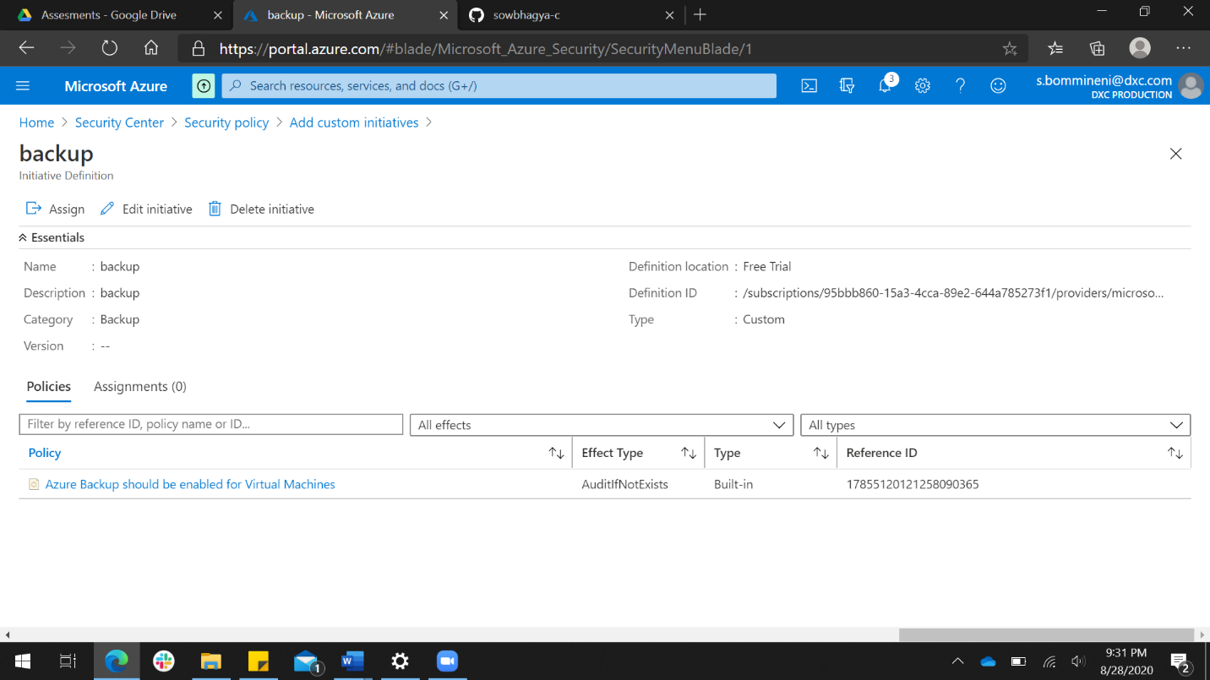

1. Create a SQL server with database installed in the elastic pool.

